- The Monetary Policy Committee held Bank Rate at 3.75%, which doesn’t justify any changes to our near-term forecast for monetary policy. We expect the MPC to keep Bank Rate unchanged this year, as the committee balances the near-term inflation shock caused by the conflict in the Middle East against a fragile labour market. Risks to the forecast are weighted toward summer tightening.
- The MPC is being patient and waiting until the impact of the Middle East conflict is clearer. Policy will be shaped by energy prices and evidence of second-round effects in terms of firms’ pricing power and the strength of pay growth. The majority of members placed the most weight on the MPC’s middle scenario, with higher energy prices than recent market pricing and modest second-round effects.
- It wouldn’t take much to tip the balance towards rate hikes. Continued strength in energy prices or evidence the MPC has underestimated indirect impacts of higher energy prices could convince the majority to hike.
The Bank of England's Monetary Policy Committee voted 8-1 to hold Bank Rate at 3.75%. The sole dissenter, Chief Economist Huw Pill, preferred a 25bp hike. But there was a wide range of views among those voting for no change, with two members suggesting they’re likely to switch their vote soon.
The MPC stressed the uncertainty caused by the Middle East conflict and framed its view of the outlook around three scenarios with varying profiles for energy prices and second-round effects. Chart 1 shows the outcomes for inflation plotted against our baseline and the prolonged war scenario.
Chart 1: The MPC presented three scenarios for inflation, with most members favouring Scenario B
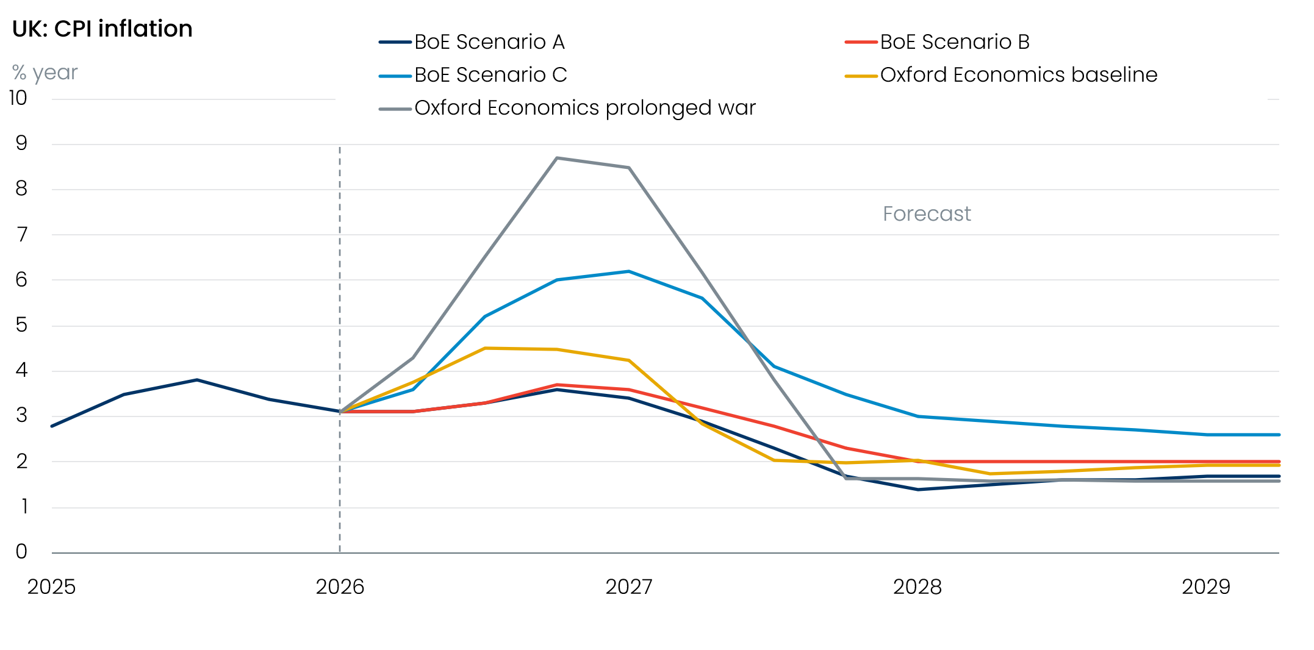
Sources: Oxford Economics, Haver Analytics

The assumptions underpinning the scenarios are:
- Scenario A: Energy prices follow market futures pricing. No second-round effects.
- Scenario B: Energy prices follow market futures pricing for six months, then stay higher. Modest second-round effects.
- Scenario C: Energy prices rise sharply and stay elevated. Strong and more persistent second-round effects.
Scenarios A and B show a smaller near-term impact on inflation than our baseline forecast but have a similar profile two years out. Scenario C implies much higher inflation than our baseline in the near term, but is less severe than our prolonged war scenario.
The individual paragraphs suggested the majority of the committee placed the most weight on Scenario B. In some cases, this was because members felt that the 15-day average market curves for oil and gas prices were too low given the damage to energy infrastructure. Most agreed that modest second-round effects were the most likely scenario, given the degree of slack and the implications for firms’ pricing power and workers’ pay bargaining power.
Apart from Pill, the other notable exceptions were Catherine Mann and Megan Greene. Mann said she expected greater second-round effects than in any of the scenarios, while Greene felt that inflation was likely to fall somewhere between Scenarios B and C. We think it’s likely that both members will vote for rate hikes soon, probably at June’s meeting.
The intentions of the other members are opaque. Modelling shown in the Monetary Policy Report suggested that all three scenarios imply some rate hikes in the near term, and Dave Ramsden said he would consider raising Bank Rate if Scenario B plays out, accepting it would mean a larger output gap. But the paragraphs of other members betrayed little urgency to hike. Most stressed the importance of second-round effects of pay and pricing power, but didn’t volunteer any precise criteria against which we could judge their likely reaction function.

Baseline forecast unchanged, but there’s a heightened risk of rate hikes
On balance, we’ll stick with our baseline (modal) forecast that Bank Rate remains on hold at 3.75% for the rest of this year. Governor Andrew Bailey characterised Thursday’s decision as an “active hold”, aided by the fact that financial conditions have already tightened, with the MPC willing to act if necessary. Our May baseline will assume that disruption in the Strait of Hormuz will be slower to clear, keeping oil and gas prices higher in early summer. But we still expect energy prices to drop back sharply in H2. This easing in energy prices and forward-looking survey evidence suggesting that second-round effects will remain modest should keep the MPC in a watching brief.
But it’s a close call, and the risks of rate hikes are much higher than they were a few weeks ago. There’s little sign of a resolution to the conflict, and if there’s continued strength in energy prices, that would probably be enough to tip the balance in favour of higher rates. In addition, the inflation forecasts for Scenarios A and B look low to us, with the MPC potentially underestimating the strength of indirect pressures from higher energy costs on the prices of other goods and services (Chart 1). If we’re right, upside surprises for inflation could be something that convinces the MPC to act, even if it’s too early to see much evidence of second-round effects on pay and firms’ pricing power.
If either of these events play out, we think there’s a good chance that the MPC will follow the ‘robust’ approach that we set out in a recent note, with a couple of hikes to mitigate the impact of high inflation becoming embedded in expectations.

